Chapter 11, Problem 58.

Obtain the complex power delivered to the 10-kΩ resistor in Fig. 11.77 below.

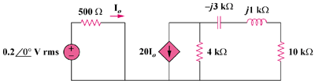

Figure 11.77
For Prob. 11.58.

